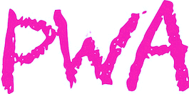

Presents:

Behind The Hustle: Business Tools for Fitness Professionals
Hosted by: Ashlee Carignan, Master Pilates Instructor
Owner of Pilates With Ashlee~ PWA | Los Angeles, CA

WHAT ARE YOU GOING TO GET OUT THIS COURSE?
BEHIND THE HUSTLE is an interactive course where all participants are encouraged to partake, engage, & share their successes! Knowledge is power-- we all learn from one another which is why I created this workshop.

The information presented in this interactive workshop will provide Instructors with the following tools:

- A comprehensive understanding of the details & "behind the scenes" work that's required to run a business.
- You’ll learn & understand by tweaking small techniques and/or approaches, you could be enhancing your practice & business by 100%.
- Each participant will leave my workshop having a better understanding of social media and its role in amplifying business success.
- The importance of Class Flow~ Where does your Teacher Inspiration come from?
- Learn from Ashlee’s 13+ years of experience, owning & operating her business/brand. How do you successfully grow a clientele? What are the most effective strategies for gaining & retaining clients?
- Participants will gain an extensive understanding of exactly what's behind the hustle and use these proven business tools to ultimately gain entrepreneurial success!

DATE: TBD
HELD AT: (STUDIO NAME)
COST: COMPLIMENTARY, ATTENDANCE ENCOURAGE BUT NOT MANDATORY
COST: EARLY BIRD $75/ $100 AFTER (DATE)
✭ RSVP AT~ INFO@PILATESWITHASHLEE.NET / (STUDIO EMAIL/#)

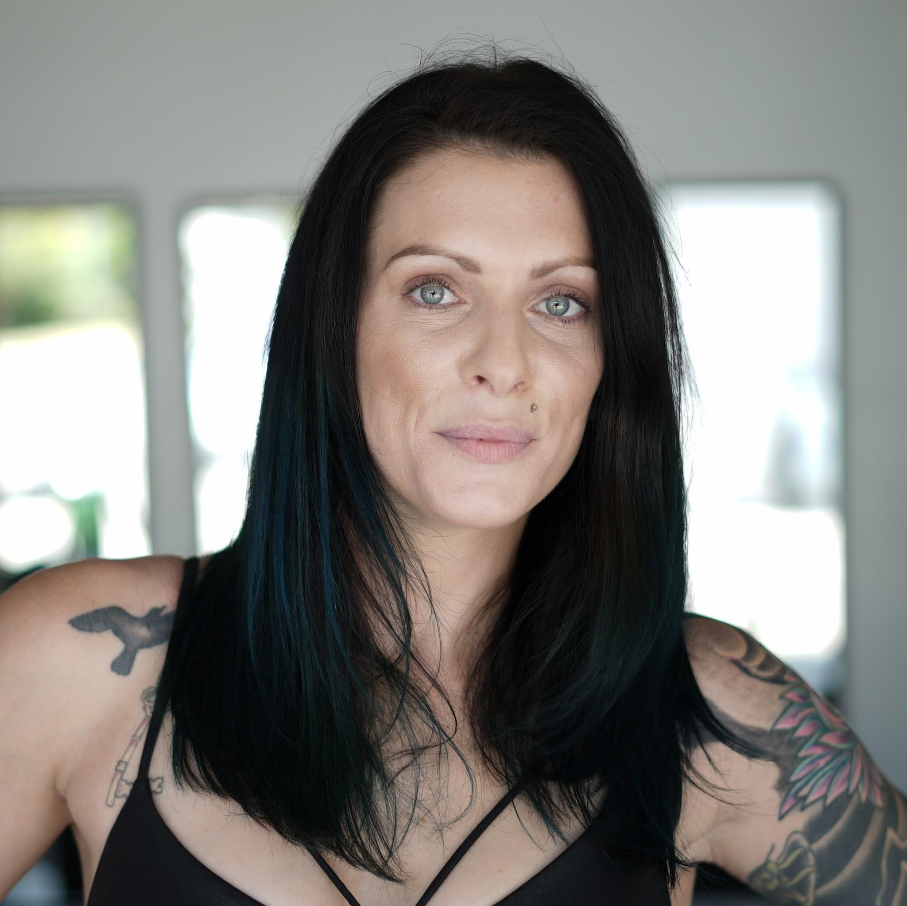

MEET ASHLEE CARIGNAN
Ashlee comes from an athletic background, including playing competitive soccer through college to a dedicated life in gyms and fitness classes. Her Pilates career began 14 years ago when she completed an intense certification program--The Ivan Dahl Method. Ashlee quickly became addicted to the practices & philosophies of Joseph Pilates. She became excited by the idea of building a career centered around Joseph’s teachings & teaching people the complete coordination between the body, mind, and spirit.

After a series of residencies at some of LA’s most popular studios, Ashlee opened her own chic-boutique studio 6 years ago in Beverlywood, appropriately called, “Pilates with Ashlee,” branded as PWA. Once expanded, Ashlee decided to go full throttle and brand her studio & self. From her own unique style of teaching, to her offbeat look & style, Ashlee stands out in more ways than one! Simultaneously, she remains one of the most influential Instagram leaders w/ 70k followers, @pilateswithashlee.

The continued growth of her company has allowed Ashlee to establish long term relationships with like- minded Fitness & Wellness brands. She believes in creating these long-term working relationships because they are ALWAYS mutually beneficial. Luckily Ashlee’s been fortunate enough to have worked with, as well as being sponsored by, some of the BEST Brands/Companies/People on the market today! In addition to past Partnership/Sponsorships, she currently Ambassador’s for these AMAZING brands: Fablectics, FabFitFun, YUNI Beauty, Motivy Fitness App, Tucketts Socks, Balanced Body, Glyder Apparel & many more.

PWA had a BIG year in 2017, advancing right into 2018 with a fully booked studio! Now Currently, PWA strives to keep outshining ourselves by launching our FIRST Workshop: Behind the Hustle- Business Tools for Fitness Professionals, which is now taking bookings!

HIGHLIGHTS & ACHIEVEMENTS:
- Recognized as the #1 Pilates Instructor in Los Angeles by ClassPass for 2017.
- Featured in US Weekly’s Celeb Sightings section for working with top Influencer Caitlyn Chase.
- Featured in & wrote PWA’s interview in The Huffington Post’s ongoing series, “5 Thing I wish I knew before opening my Startup,”
- Pilates Style Magazine wrote an article on a series of Hashtags I created on Instagram, which digitally categorized/archived Pilates exercises, called “The #FOREVERYONE Index.”
- PWA has been featured in Voyage LA, LA Weekly,, Focus Magazine, CBS’s hit show, “This is LA!”, & now live on FabFitFun TV~ 8 Instructional Workout segments!
- Hosted 2 Carbon38 Events & upcoming this March 2020, Ashlee will host an event for Fabletics!

